CAS PY 106

Pre-session Note 1

Electric Charge

1. Triboelectric Series
2. An object can acquire a net charge by touching another material. Which material acquires electrons is determined by where the material fit in the triboelectric Series
3. **More Positive**

Rabbit’s fur

Glass

Nylon

Cat’s fur

Silk

Polyethylene

Rubber balloon

**More Negative**

1. When materials are rubbed together, the one higher up the list gives electrons to the one further down the list.
2. Ex) Nylon is higher up than felt, so nylon gives up electrons, becoming positive, when rubbed with felt and felt becomes negative
3. Ex) Rubber is lower than fur, so rubber acquires electrons and becomes negative, while fur becomes positive
4. Rubbing promotes charge transfer, causing chemical bonds (which involve electrons) to form between them
5. Basic Model of electric charge
6. Two types of charge, positive and negative
7. Objects, which mostly have equal number of electrons and protons (has no net charge), generally charged by either acquiring extra electrons (net negative charge), giving up electrons (net positive charge)
8. Forces between charged objects can be very large. Such forces are really what stop us from falling through the floor, for instance. In other words, what we called the normal force is really associated with repulsive forces between electrons.
9. Symbol for charge is Q or q
10. The unit is Coulomb (C)
11. Charge is quantized
12. Charge is quantized – in general, charge comes in integer multiples of e, the magnitude of the charge on the electron

e = 1.60 * 10^-19 C

1. An electron has charge of –e; a proton has a charge of +e
2. Conductors and Insulators
3. Metals generally have conductivities that are orders of magnitude larger than the conductivities of materials like rubber and plastic, known as insulators.
4. The major difference is that in an insulator, each electron is closely tied to its molecule (electrons are harder to move around since they are tied together), while some fraction of the electrons in conductor are free to move around
5. Some elementary particles

Particle Mass Charge

Electron 9.11*10^-31kg -e = -1.60 * 10^-19 C

Proton 1.672 * 10^-27kg e = 1.60 * 10^19 C

Neutron 1.674 * 10^-27 kg 0

1. Charge is conserved
2. Charge is conserved – the net charge in a closed system is constant
3. As long as we allow the two identical objects to touch in a way that no charge is transferred in or out of the system (closed system), we can use the idea that charge is conserved – the net charge in the system must be constant at all times
4. Example) Two identical metal spheres are charged. Sphere A has charge of 7Q and B has charge of -3Q. The spheres are brought together and touched and separated. The net charge on each sphere is 7+(-3) Q = 4Q. When separated, they take the net charge equally giving 4Q/2 = 2Q to both spheres. (the sphere with 7Q takes electrons from the sphere with -3Q – the electrons are the ones that are moving, not protons)
5. Classifying materials
6. We can classify materials into three broad categories, based on how easily charge flows through them.
7. Conductors” charge flows easily (ex- metals)
8. Semi-conductors: charge flows, but not easily
9. Insulators: very little charge flows
10. Application: a power cord you plug into a wall socket has two conducting wires to carry electricity to your cell phone and back, but the wires are wrapped with a rubber coating so you do not get a shock
11. Charging by Induction
12. Uncharged conducting object like metal sphere can be charged by rubbing it with charged rod acquiring charge of the same sign as that of the rod
13. However, it can also be charged without touching it with a charged rod, known as charging by induction
14. 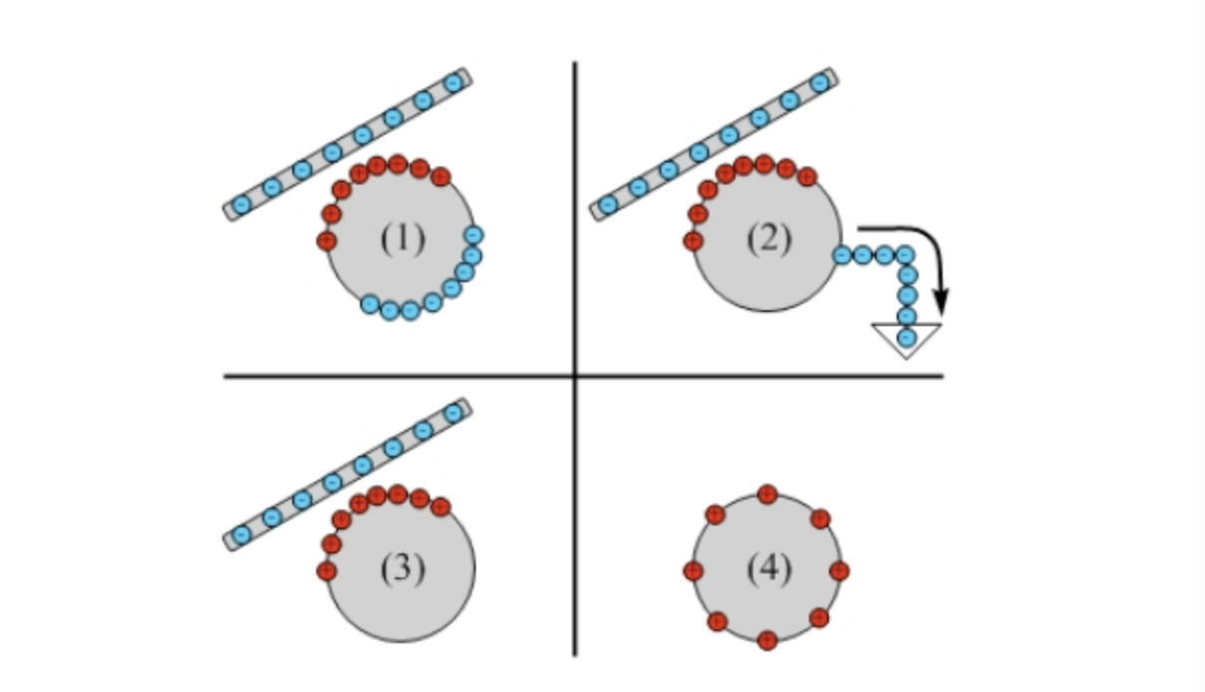
15. Ground takes both negative and positive and attracts both charges
16. An electroscope
17. 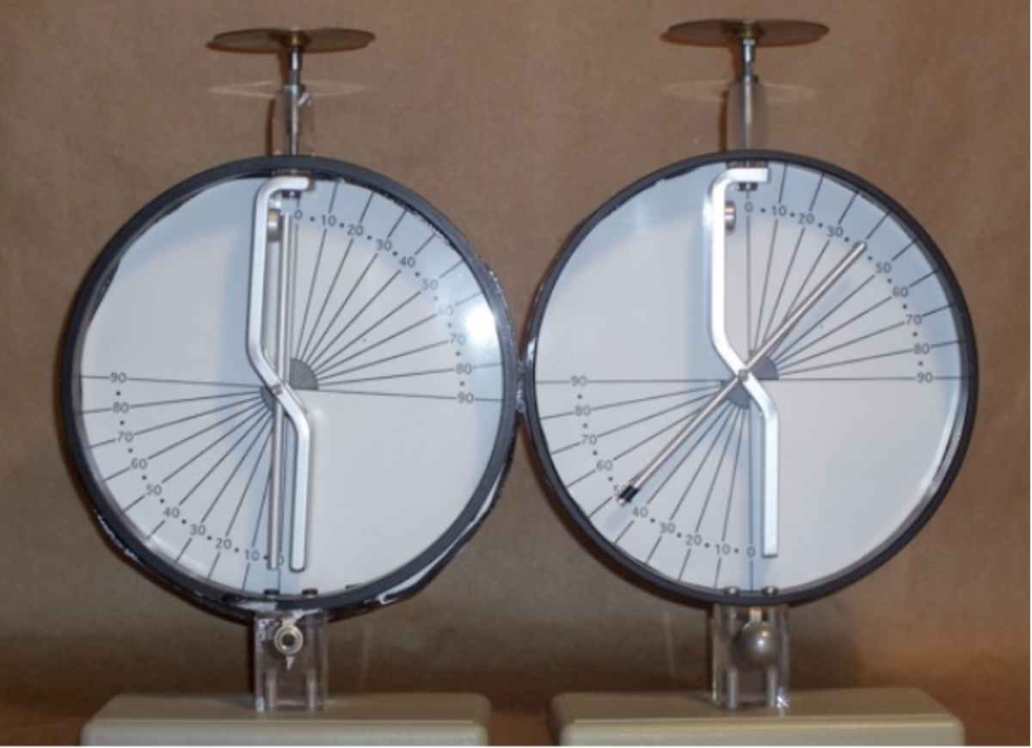
18. When electroscope is charged, the charge distributes itself over the entire electroscope because it is made from conducting material
19. Like charges repel, so electroscope’s arm swings out. The larger the charge, the more arm swings out
20. Electroscope and a charged rod
21. Electroscope is always neutral, even at beginning.
22. When bringing rod closer to electroscope, it acts like it is charged even though it isn’t. It becomes polarized (the net charge is the same but there exists a section where the material is more positive and more negative due to the difference in number of electrons in each sections of the material).
23. If rod has positive charge, electrons in electroscope are attracted toward the rod and the electrons move toward the top plate, leaving net positive charge on and near the needle, which deflects since like charges repel
24. 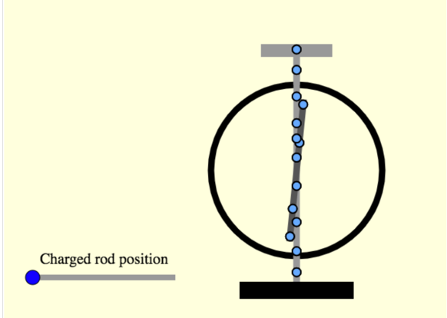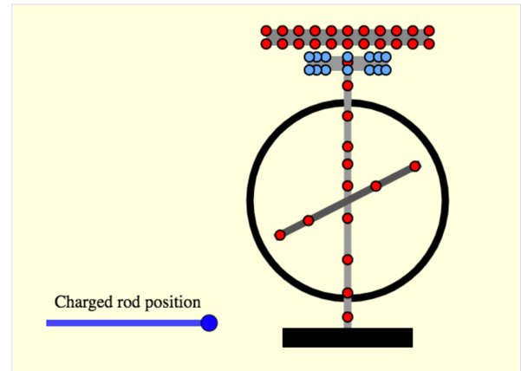
25. If rod has a negative charge, electrons in top plate of the electroscope are repelled by electrons on the rod. The electrons on the electroscope move toward the needle, which deflects since like charges repel
26. 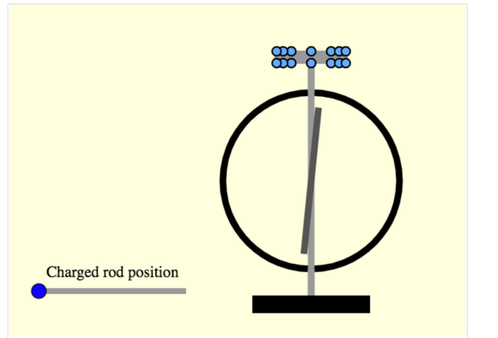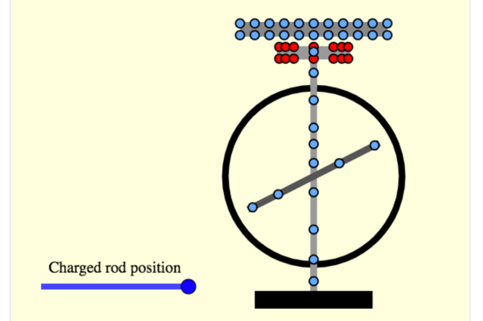
27. An electroscope responds to the presence of a charge by moving electrons into or away from the leaves. In both cases, leaves separate
28. Important to note that electroscope cannot determine if the charged object is positive or negative